3G622R(3G622R+)-How to setup 3G WAN mode?
Product line: 3G Question category: Internet settings

The Steps are as below:
1．Please plug the 3G modem on your computers and install the Program for 3G USB modem ,Then connect to the internet, please record the relevant parameters that you need type in the 3G setting page of 3G router on the program installed for 3G modem(like the picture attached)
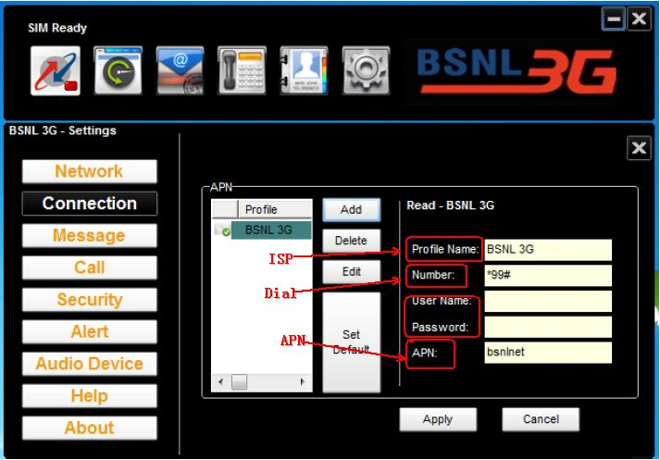
2．Please plug your 3G modem on the router and connect your computer to the LAN port on the router with Ethernet cable.
Then login to the router management page through type http://192.168.0.1 in the address bar in your web browser,
A pop-up will appear and require you input username and password, both of them default are admin.
3．Click WAN Medium and select 3G WAN mode to configure 3G router.
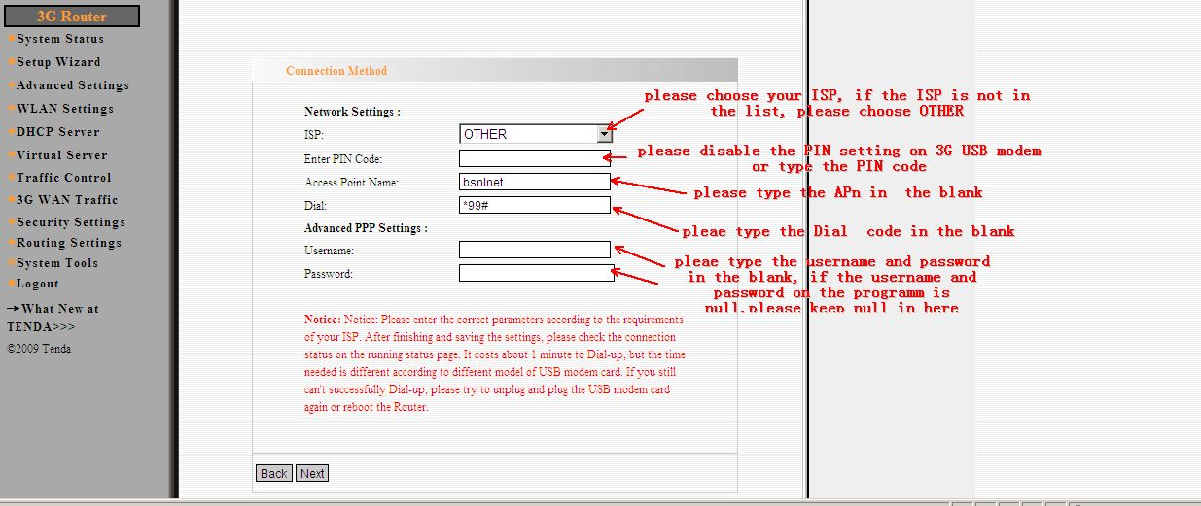
After you finished configure 3G WAN setting and save the settings.
Please click System Status to check whether the router have obtained WAN IP. If the router failed to connect to internet
please send us the picture of 3G WAN setting, System log, and the picture of software installed in the computer for 3G modem that used to connect to internet when the modem plug on the computer directly, and the log information
The way to get log: http://192.168.0.1/ppplog.txt
or http://192.168.0.1/usbdongle.log

